Dedicated audiologists use clever tools to combat hearing loss
By Larine Barr, DoD Hearing Center of Excellence

Navy occupational audiologist Lt. Laura Stephenson has helped roughly 20,000 patients better understand how exposure to hazardous noise at work and off-duty can cause a devastating, invisible injury called noise-induced hearing loss.
According to the Centers for Disease Control and Prevention, noise-induced hearing loss, or NIHL, is usually caused by exposure to excessively loud sounds and cannot be medically or surgically corrected. It can result from a one-time exposure to a very loud sound, blast, or impulse, or from listening to loud sounds over an extended period.
Hearing loss and tinnitus (the perception of sound – sometimes a ringing sound - without an external source being present) have steadily increased over the last two decades among Veterans. A Fiscal Year 2017 report released by the Veterans Benefits Administration found that 1.6 million and 1.1 million Veterans receive disability compensation for tinnitus and hearing loss, respectively.
With prevention in mind, Stephenson, who is assigned to Naval Hospital Jacksonville, Fla., set out in 2016 to reduce hearing loss among local Service members and their families. She helped to boost awareness using an array of educational tools available through the Comprehensive Hearing Health Program, or CHHP, developed by the Department of Defense Hearing Center of Excellence.
The CHHP was created in 2013 and is currently being launched across the DoD and VA to reduce the incidence of NIHL through education, protection and monitoring efforts. The education component includes patient-education sessions during audiology and hearing conservation appointments augmented with HCE-designed educational materials such as brochures, work books and flip charts.

Col. LaKeisha Henry, HCE division chief, said CHHP was implemented to optimize the current DoD hearing conservation programs, and to serve the non-occupationally exposed, since exposure to hazardous noise can occur off-duty yet impact a Service members' performance while on duty.

“When I first started using the CHHP materials, I ordered one of everything for our occupational nurses, audiologists, and technicians to use,” explained Stephenson, who distributes the materials at the Jacksonville hospital and its five branch health clinics. “Our nurses really like the flip charts on speech communication, and our technicians use the sound tracks poster, different degrees of hearing loss posters, and what the colors mean on your hearing test (audiogram) scores. We’ve also gotten great feedback on the tinnitus work book. It’s awesome and really beneficial.”
Stephenson said the program has especially helped to bring awareness to the installation’s safety managers. “They now know what to look for in hearing protection devices. This really drives the prevention element. Compliance is huge and that’s why our safety managers exist,” she said.
Since implementing the CHHP, Stephenson said she’s seen less hearing loss among her patients.
Maj. William Gottlick, an audiologist at Lyster Army Health Clinic at Fort Rucker, Ala., is another strong CHHP advocate. He started the program in 2014 while assigned at Tripler Army Medical Center, Hawaii, and has continued to embrace it at Fort Rucker.
Gottlick said he and his staff use the ABC approach: advertising, briefings and counseling, to administer the CHHP at his clinic. "For the advertising element at Tripler, we distributed posters and pamphlets and held an internal health fair so other providers would stop by. The most interested were our behavioral health providers. They understood the relationship between TBI, PTSD and hearing loss and tinnitus."

Gottlick said his technicians at Lyster deliver an educational briefing using CHHP materials to Soldiers before their hearing tests and audiologists use the flip charts to discuss the physiologic process of hearing loss with their patients.

To further tailor the materials, Gottlick and the Lyster Audiology staff crafted their own 10-minute educational video by combining key points from several HCE-produced CHHP videos. They play the video when Soldiers come in for their annual hearing test and hearing protection fitting.

“A large amount of patients don’t comprehend the dangers,” Gottlick stressed. “Having these materials is definitely beneficial. There is something for everyone—hearing education, protection and hearing devices. Its purpose has been fulfilled.”
The CHHP educational materials can be viewed from the HCE website at hearing.health.mil, under resources, audio and print materials. These resources are free to DoD/VA providers, and can be ordered via the Government Printing Office link on the HCE website and sent directly to clinics.

--30—

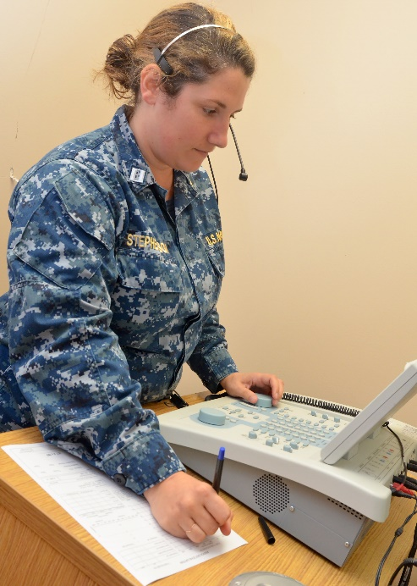
171024-N-AW702-018
Lt. Laura Stephenson, occupational audiologist at Naval Hospital Jacksonville, conducts audiologic diagnostic testing at Naval Branch Health Clinic Kings Bay's occupational health clinic. (Navy photo)

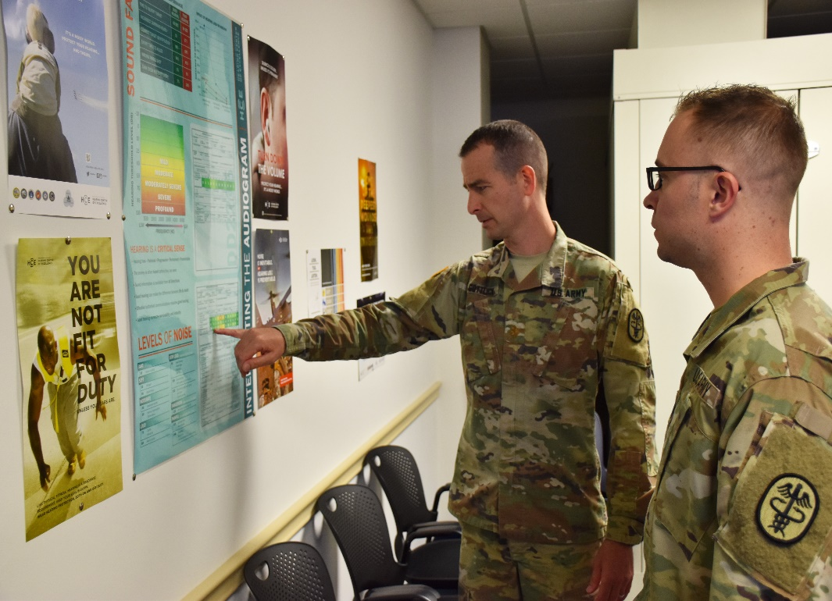
Army audiologist Maj. William Gottlick, Lyster Army Health Clinic, Fort Rucker, Ala., uses the “Interpreting the Audiogram” poster from the Comprehensive Hearing Health Program educational materials to counsel a Soldier after he received his annual hearing test. (Photo by Jennifer Stripling/Lyster Army Health Clinic)
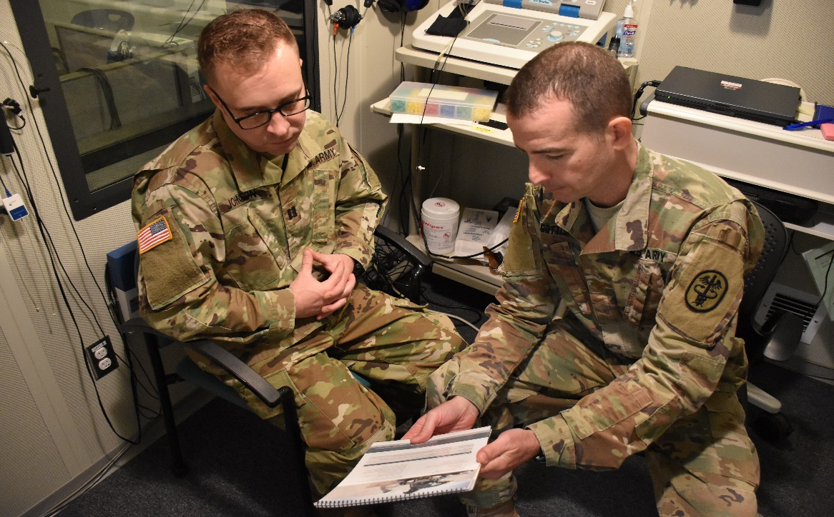
Army audiologist Maj. William Gottlick, Lyster Army Health Clinic, Fort Rucker, Ala., counsels a Soldier on noise hazards and reduction strategies using the Hearing Guide flip chart from the CHHP educational materials provided by the DoD Hearing Center of Excellence. (Photo by Jennifer Stripling/Lyster Army Health Clinic)

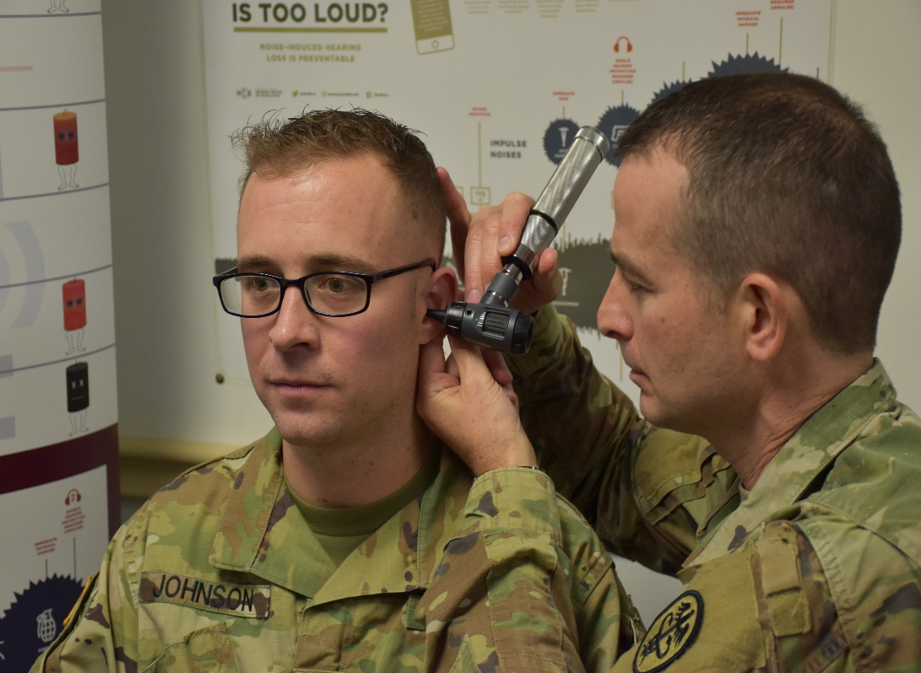
Army audiologist Maj. William Gottlick (right), Lyster Army Health Clinic, Fort Rucker, Ala., conducts an otoscopic exam during an annual hearing test. (Photo by Jennifer Stripling/Lyster Army Health Clinic)

